PRODUCT INFORMATION SHEET

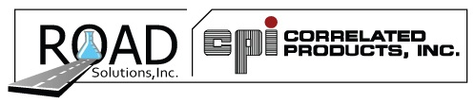

5616 Progress Road
Indianapolis, Indiana 46241
1(800)428-3266 www.CPIRoadSolutions.com

CPI Correl-lube White
White Lithium Grease Lubricant

DESCRIPTION
CPI Correl-lube White is a multi-purpose lithium lubricant. It contains zinc oxide in a fine micron particle size and a high viscosity index oil which adds to the lubricity of the product and also acts as a corrosion inhibitor.

FEATURES AND BENEFITS
Sprays as a liquid, quickly air cures to a thick grease. Resists water washout. Prevents rust and corrosion. Outstanding tenacity- clings to metal and will not run.

APPLICATIONS AND USES
For use on automotive hinges and springs, industrial machinery and tools, marine linkages and cables, and farm machinery.

DIRECTIONS FOR USE
Shake can well before using and between applications. Spray parts. If necessary, repeat application. Avoid overspray of floors and walkways.

SIZE / AVAILABILITY
16 oz. Aerosol Net Weight 11 oz. 12 per case
VOC Weight: 50.0%

1 1
1 1 0
0
B

