SAFETY DATA SHEET

SECTION 1) CHEMICAL PRODUCT AND SUPPLIER'S IDENTIFICATION

Product ID: Product Name:  Revision Date: | 496605  CPI Correl-lube White  Nov 19, 2015 | Date Printed: | Nov 19, 2015
Version: | 1.0 | Supersedes Date: | N.A.
Manufacturer's Name:  Address: | Zenex International  1 Zenex Circle Cleveland, OH, US, 44146
Emergency Phone: | 1-800-535-5053
Information Phone Number: (440)-232-4155

Fax:
Product/Recommended Uses: White Lithium Grease

SECTION 2) HAZARDS IDENTIFICATION

Classification:
Aspiration Hazard - Category 1 Skin Irritation - Category 2 Aerosol - Category 1

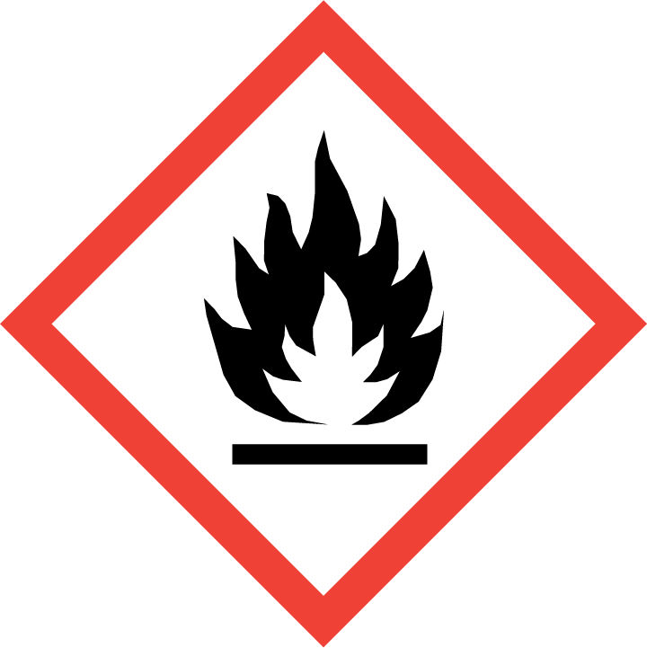
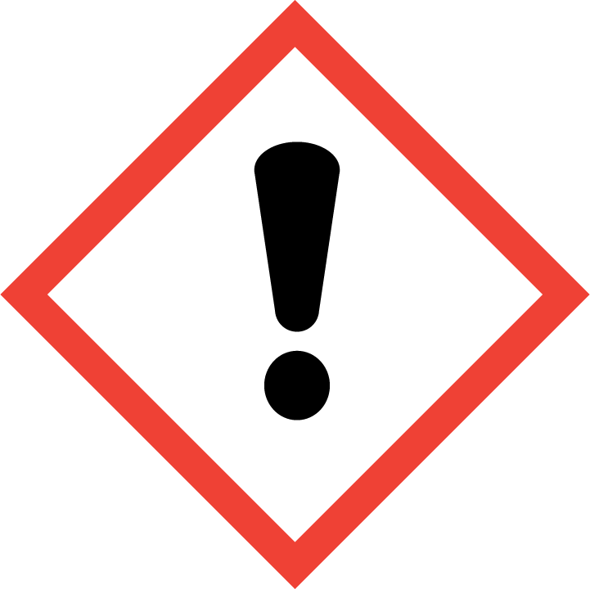
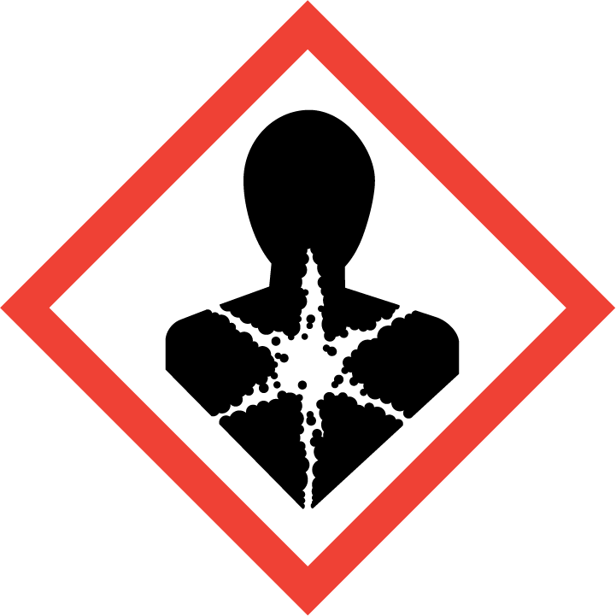
Pictograms:
Signal Word:
Danger

Hazardous Statements - Physical:
H222, H229 - Extremely flammable aerosol, Pressurized container may burst if heated

Hazardous Statements - Health:
H304 - May be fatal if swallowed and enters airways H315 - Causes skin irritation

Precautionary Statements - General:
P101 - If medical advice is needed, have product container or label at hand. P102 - Keep out of reach of children.
P103 - Read label before use.

Precautionary Statements - Prevention:
P264 - Wash thoroughly after handling. P280 - Wear eye protection/face protection.
P210 - Keep away from heat, hot surfaces, sparks, open flames and other ignition sources. No smoking. P211 - Do not spray on an open flame or other ignition source.
P251 - Do not pierce or burn, even after use.

Precautionary Statements - Response:
P301 + P310 - IF SWALLOWED: Immediately call a POISON CENTER or doctor/physician. P331 - Do NOT induce vomiting.
P302 + P352 - IF ON SKIN: Wash with plenty of soap and water.

P332 + P313 - If skin irritation occurs: Get medical advice/attention. P362 + P364 - Take off contaminated clothing and wash it before reuse.

Precautionary Statements - Storage:
P405 - Store locked up.
P403 + P235 - Store in a well-ventilated place. Keep cool.
P410 - Protect from sunlight.
P412 - Do not expose to temperatures exceeding 50°C/122°F.

Precautionary Statements - Disposal:

P501 - Dispose of contents and container in accordance with all local, regional, national and international regulations.

SECTION 3) COMPOSITION / INFORMATION ON INGREDIENTS
CAS | Chemical Name | % By Weight
0064742-52-5 | MINERAL OIL, PETROLEUM DISTILLATES, HYDROTREATED (MILD) HEAVY | 23% - 41%
 | NAPHTHENIC
0000106-97-8  0064742-47-8 | BUTANE  ISOPARAFFINIC PETROLEUM DISTILLATE | 10% - 26%  6% - 16%
0000075-28-5 | ISOBUTANE | 5% - 12%
0000074-98-6 | PROPANE | 4% - 11%
0007620-77-1 | Lithium soap | 1% - 2%

SECTION 4) FIRST-AID MEASURES

Inhalation:
Remove source of exposure or move person to fresh air and keep comfortable for breathing. If exposed/feel unwell/concerned: Call a POISON CENTER/doctor.
Eliminate all ignition sources if safe to do so.

Eye Contact:
Remove source of exposure or move person to fresh air. Rinse eyes cautiously with lukewarm, gently flowing water for several minutes, while holding the eyelids open. Remove contact lenses, if present and easy to do. Continue rinsing for a duration of 15-20 minutes. Take care not to rinse contaminated water into the unaffected eye or onto the face. If eye irritation persists: Get medical advice/attention.

Skin Contact:
Take off immediately all contaminated clothing, shoes and leather goods (e.g. watchbands, belts). Gently blot or brush away excess product. Wash with plenty of lukewarm, gently flowing water for a duration of 15-20 minutes. Call a POISON CENTER/doctor if you feel unwell. Store contaminated clothing under water and wash before reuse or discard.

Ingestion:
Rinse mouth. Do NOT induce vomiting. Immediately call a POISON CENTER/doctor. If vomiting occurs naturally, lie on your side, in the recovery position.
Never give anything by mouth to an unconscious or convulsing victim. Keep person warm and quiet.

SECTION 5) FIRE-FIGHTING MEASURES

Suitable Extinguishing Media:

Use water, fog, dry chemical, or carbon dioxide. Carbon dioxide can displace oxygen. Use caution when applying carbon dioxide in confined spaces. Simultaneous use of foam and water on the same surface is to be avoided as water destroys the foam.

Unsuitable Extinguishing Media:
Water may be ineffective but can be used to cool containers exposed to heat or flame.

Specific Hazards in Case of Fire:
Contents under pressure. Keep away from ignition sources and open flames. Exposure of containers to extreme heat and flames can cause them to rupture often with violent force.
Aerosol cans may rupture when heated. Heated cans may burst. In fire, will decompose to carbon dioxide, carbon monoxide

Fire-Fighting Procedures:
Isolate immediate hazard area and keep unauthorized personnel out. Stop spill/release if it can be done safely. Move undamaged containers from immediate hazard area if it can be done safely. Water spray may be useful in minimizing or dispersing vapors and to protect personnel.
Dispose of fire debris and contaminated extinguishing water in accordance with official regulations.

Special Protective Actions:
Wear protective pressure self-contained breathing apparatus (SCBA)and full turnout gear. Care should always be exercised in dust/mist areas.

SECTION 6) ACCIDENTAL RELEASE MEASURES

Emergency Procedure:
Flammable/combustible material. ELIMINATE all ignition sources (no smoking, flares, sparks, or flames in immediate area). Stay upwind; keep out of low areas. Immediately turn off or isolate any source of ignition. Keep unnecessary people away; isolate hazard area and deny entry. Do not touch or walk through spilled material. Clean up immediately. Use absorbent sweeping compound to soak up material and put into suitable container for proper disposal.

Recommended Equipment:
Positive pressure, full-face piece self-contained breathing apparatus(SCBA), or positive pressure supplied air respirator with escape SCBA (NIOSH approved).

Personal Precautions:
ELIMINATE all ignition sources (no smoking, flares, sparks, or flames in immediate area). Use explosion proof equipment. Avoid breathing vapor. Avoid contact with skin, eye or clothing. Do not touch damaged containers or spilled materials unless wearing appropriate protective clothing.

Environmental Precautions:
Stop spill/release if it can be done safely. Prevent spilled material from entering sewers, storm drains, other unauthorized drainage systems and natural waterways by using sand, earth, or other appropriate barriers.

SECTION 7) HANDLING AND STORAGE

General:
For industrial and institutional use only. For use by trained personnel only. Keep away from children. Wash hands after use. Do not get in eyes, on skin or on clothing. Do not breathe vapors or mists. Use good personal hygiene practices. Eating, drinking and smoking in work areas is prohibited. Remove contaminated clothing and protective equipment before entering eating areas. Eyewash stations and showers should be available in areas where this material is used and stored.

Ventilation Requirements:
Use only with adequate ventilation to control air contaminants to their exposure limits. The use of local ventilation is recommended to control emissions near the source.

Storage Room Requirements:
Keep container(s) tightly closed and properly labeled. Store in cool, dry, well-ventilated areas away from heat, direct sunlight and incompatibilities. Store in approved containers and protect against physical damage. Keep containers securely sealed when not in use. Indoor storage should meet OSHA standards and appropriate fire codes. Containers that have been opened must be carefully resealed to prevent leakage. Empty container retain residue and may be dangerous.
Do not cut, drill, grind, weld, or perform similar operations on or near containers. Do not pressurize containers to empty them. Ground all structures, transfer containers and equipment to conform to the national electrical code. Use procedures that prevent static electrical sparks. Static electricity may accumulate and create a fire hazard.
Store at temperatures below 120°F.

SECTION 8) EXPOSURE CONTROLS, PERSONAL PROTECTION

Eye Protection:

Chemical goggles, safety glasses with side shields or vented/splash proof goggles. Contact lenses may absorb irritants. Particles may adhere to lenses and cause corneal damage.

Skin Protection:
Wear gloves, long sleeved shirt, long pants and other protective clothing as required to minimize skin contact.
Use of gloves approved to relevant standards made from the following materials may provide suitable chemical protection: PVC, neoprene or nitrile rubber gloves. Suitability and durability of a glove is dependent on usage, e.g. frequency and duration of contact, chemical resistance of glove material, glove thickness, dexterity. Always seek advice from glove suppliers. Contaminated gloves should be replaced. Chemical-resistant clothing is recommended to avoid prolonged contact. Avoid unnecessary skin contact.

Respiratory Protection:
If engineering controls do not maintain airborne concentrations to a level which is adequate to protect worker, a respiratory protection program that meets or is equivalent to OSHA 29 CFR 1910.134 and ANSI Z88.2 should be followed. Check with respiratory protective equipment suppliers. Where air-filtering respirators are suitable, select an appropriate combination of mask and filter. Select a filter suitable for combined particulate/organic gases and vapors.
When spraying more than one half can continuously or more than one can consecutively, use NIOSH approved respirator.

Chemical Name | OSHA TWA  (ppm) | OSHA TWA  (mg/m3) | OSHA STEL  (ppm) | OSHA STEL  (mg/m3) | OSHA  Tables (Z1, Z2, Z3) | OSHA  Carcinogen | OSHA  Skin designation | NIOSH TWA  (ppm) | NIOSH TWA  (mg/m3) | NIOSH STEL  (ppm) | NIOSH STEL  (mg/m3) | NIOSH  Carcinogen
BUTANE |  |  |  |  |  |  |  | 800 | 1900
ISOBUTANE |  |  |  |  |  |  |  | 800 | 1900
ISOPARAFFINIC PETROLEUM DISTILLATE | 500 | 2000 |  |  | 1
MINERAL OIL, PETROLEUM DISTILLATES, HYDROTREATED (MILD) HEAVY NAPHTHENIC | 500 | 2000 |  |  | 1
PROPANE | 1000 | 1800 |  |  | 1 |  |  | 1000 | 1800

Chemical Name | ACGIH TWA  (ppm) | ACGIH TWA  (mg/m3) | ACGIH STEL  (ppm) | ACGIH STEL  (mg/m3)
BUTANE | 1000
ISOBUTANE | 1000
ISOPARAFFINIC PETROLEUM DISTILLATE
MINERAL OIL, PETROLEUM DISTILLATES, HYDROTREATED (MILD) HEAVY NAPHTHENIC
PROPANE | See Appendix F: Minimal Oxygen Content

SECTION 9) PHYSICAL AND CHEMICAL PROPERTIES

Physical and Chemical Properties

Density 6.42255 lb/gal
Density VOC 3.21127 lb/gal
% VOC 50.00000%
VOC Actual 3.21127 lb/gal
VOC Actual 384.80688 g/l
VOC Regulatory 3.21127 lb/gal
VOC Regulatory 384.80688 g/l
Appearance White grease
Odor Threshold N.A.
Odor Description N.A.
pH N.A.
Water Solubility Nil
Flammability Flashpoint below 73 °F
Flash Point Symbol N.A.
Flash Point N.A.
Viscosity N.A.
Lower Explosion Level N.A.
Upper Explosion Level N.A.
Vapor Density Slower than ether
Melting Point N.A.
Freezing Point N.A.
Low Boiling Point N.A.
High Boiling Point N.A.
Decomposition Pt 0
Auto Ignition Temp N.A.
Evaporation Rate Slower than ether

SECTION 10) STABILITY AND REACTIVITY

Stability:
Stable.

Conditions to Avoid:
High temperatures.

Incompatible Materials:
None known.

Hazardous Reactions/Polymerization:
Will not occur.

Hazardous Decomposition Products:
In fire, will decompose to carbon dioxide, carbon monoxide.

SECTION 11) TOXICOLOGICAL INFORMATION

Skin Corrosion/Irritation:
Overexposure will cause defatting of skin. Causes skin irritation

Serious Eye Damage/Irritation:
Overexposure will cause redness and burning sensation.

Carcinogenicity:
No data available

Germ Cell Mutagenicity:

No data available

Reproductive Toxicity:
No data available

Respiratory/Skin Sensitization:
No data available

Specific Target Organ Toxicity - Single Exposure:
No data available

Specific Target Organ Toxicity - Repeated Exposure:
No data available

Aspiration Hazard:
May be fatal if swallowed and enters airways

Acute Toxicity:
Inhalation: effect of overexposure include irritation of respiratory tract, headache, dizziness, nausea, and loss of coordination. Extreme overexposure may result in unconsciousness and possibly death.
0064742-52-5 MINERAL OIL, PETROLEUM DISTILLATES, HYDROTREATED (MILD) HEAVY NAPHTHENIC
LD50 (Rodent - rat, Oral) : >5000 mg/kg, Toxic effects : Details of toxic effects not reported other than lethal dose value.
LD50 (Rodent - rabbit, Administration onto the skin) : >2000 mg/kg, Toxic effects : Details of toxic effects not reported other than lethal dose value.

0000075-28-5 ISOBUTANE
LC50 (mouse, inhalation): 520,000 ppm (52%); 2-hour exposure.(4) 0000106-97-8 BUTANE
LC50 (mouse): 202000 ppm (481000 mg/m3) (4-hour exposure); cited as 680 mg/L (2-hour exposure) (9) LC50 (rat): 276000 ppm (658000 mg/m3) (4-hour exposure); cited as 658 mg/L (4- hour exposure) (9)

SECTION 12) ECOLOGICAL INFORMATION

Toxicity:
No data available.

Persistence and Degradability:
No data available.

Bio-Accumulative Potential:
No data available.

Mobility in Soil:
No data available.

Other Adverse Effects:
No data available.

Bio-accumulative Potential
0064742-47-8 ISOPARAFFINIC PETROLEUM DISTILLATE
Contains constituents with the potential to bio accumulate.
0064742-52-5 MINERAL OIL, PETROLEUM DISTILLATES, HYDROTREATED (MILD) HEAVY NAPHTHENIC
Contains constituents with the potential to bioaccumulate.

Mobility in Soil
0064742-47-8 ISOPARAFFINIC PETROLEUM DISTILLATE
Floats on water. Contains volatile constituents. Evaporates within a day from water or soil surfaces. Large volumes may penetrate soil and could contaminate groundwater.
0064742-52-5 MINERAL OIL, PETROLEUM DISTILLATES, HYDROTREATED (MILD) HEAVY NAPHTHENIC
Liquid under most environmental conditions. Floats on water. If it enters soil, it will adsorb to soil particles and will not be mobile.

Persistence and Degradability
0064742-47-8 ISOPARAFFINIC PETROLEUM DISTILLATE
Expected to be inherently biodegradable. The volatile constituents will oxidize rapidly by photochemical reactions in air.

SECTION 13) DISPOSAL CONSIDERATIONS

Water Disposal:
Under RCRA, it is the responsibility of the user of the product, to determine a the time of disposal whether the product meets RCRA criteria for hazardous waste. Waste management should be in full compliance with federal, state, and local laws.
Empty containers retain product residue which may exhibit hazards of material, therefore do not pressurize, cut, glaze, weld or use for any other purposes. Return drums to reclamation centers for proper cleaning and reuse.

SECTION 14) TRANSPORT INFORMATION

DOT Information:
Consumer Commodity, ORM-D

IMDG Information:
Consumer Commodity, ORM-D

IATA Information:
Consumer Commodity, ORM-D

SECTION 15) REGULATORY INFORMATION

CAS | Chemical Name | % By Weight | Regulation List
0064742-52-5 | MINERAL OIL, PETROLEUM DISTILLATES, HYDROTREATED (MILD) HEAVY NAPHTHENIC | 23% - 41% | SARA312,VOC,TSCA,OSHA
0000106-97-8 | BUTANE | 10% - 26% | SARA312,VOC,TSCA,ACGIH
0064742-47-8 | ISOPARAFFINIC PETROLEUM DISTILLATE | 6% - 16% | SARA312,VOC,TSCA,OSHA
0000075-28-5 | ISOBUTANE | 5% - 12% | SARA312,VOC,TSCA,ACGIH
0000074-98-6 | PROPANE | 4% - 11% | SARA312,VOC,TSCA,ACGIH,OSHA
0007620-77-1 | Lithium soap | 1% - 2% | SARA312,TSCA

SECTION 16) OTHER INFORMATION

Glossary:

* There are points of differences between OSHA GHS and UN GHS. In 90% of the categories, they can be used interchangeably, but for the Skin Corrosion/Irritant Category and the Specific Target Organ Toxicity (Single and Repeated Exposure) Categories. In these cases, our system will say UN GHS.
ACGIH- American Conference of Governmental Industrial Hygienists; ANSI- American National Standards Institute; Canadian TDG- Canadian Transportation of Dangerous Goods; CAS- Chemical Abstract Service; Chemtrec- Chemical Transportation Emergency Center (US); CHIP- Chemical Hazard Information and Packaging; DSL- Domestic Substances List; EC- Equivalent Concentration; EH40 (UK)- HSE Guidance Note EH40 Occupational Exposure Limits; EPCRA- Emergency Planning and Community Right-To-Know Act; ESL- Effects screening levels; HMIS- Hazardous Material Information Service; LC- Lethal Concentration; LD- Lethal Dose; NFPA- National Fire Protection Association; OEL- Occupational Exposure Limits; OSHA- Occupational Safety and Health Administration, US Department of Labor; PEL- Permissible Exposure Limit; SARA (Title III)- Superfund Amendments and Reauthorization Act; SARA 313- Superfund Amendments and Reauthorization Act, Section 313; SCBA- Self-Contained Breathing Apparatus; STEL- Short Term Exposure Limit; TCEQ
    - Texas Commission on Environmental Quality; TLV- Threshold Limit Value; TSCA- Toxic Substances Control Act Public Law 94-469; TWA
    - Time Weighted Value; US DOT- US Department of Transportation; WHMIS- Workplace Hazardous Materials Information System.

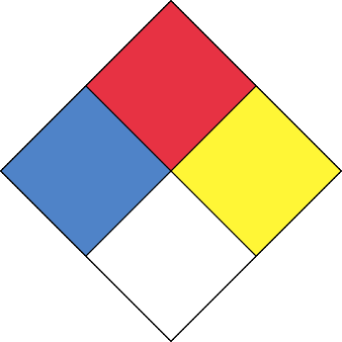
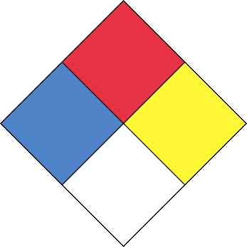
HMIS
3
1
0
B
3
1
0

Chronic :

DISCLAIMER
To the best of our knowledge, the information contained herein is accurate. However, neither the above named supplier nor any of its subsidiaries assumes any liability whatsoever for the accuracy or completeness of the information contained herein. Final determination of suitability of any material is the sole responsibility of the user. All materials may present unknown hazards and should be used with caution. Although certain hazards are described herein, we cannot guarantee that these are the only hazards that exist. The above information pertains to this product as currently formulated, and is based on the information available at this time. Addition of reducers or other additives to this product may substantially alter the composition and hazards of the product. Since conditions of use are outside our control, we make no warranties, express or implied, and assume no liability in connection with any use of this information.

