PRODUCT DATA SHEET
DYNAMITE SO CLEAR
NON-AMMONIATED READY-TO-USE GLASS & ALL PURPOSE CLEANER
Specially formulated with a balanced blend of grease cutting surfactants and solvents to quickly penetrate and remove dirt, soot, fingerprints, perspiration, and food soil on glass and other hard non-porous surfaces. Cleans, shines, and polishes.

ADVANTAGES DIRECTIONS
- Will not streak or smear. Ready to use. Spray on surface to be cleaned. Rub dry with aclean, lint-free cloth.

- Contains no ammonia - no strong ammonia odor.

- Polishes glass crystal clear, squeaky clean.

- Convenient - no diluting, no measuring. Simply spray, then rub dry with aclean, soft cloth.

Can be used on most washable surfaces. If you are in doubt, try on a small area before proceeding.

- Versatile -excellent for cleaning windows, walls, glass, chairs, cabinets, vinyl, porcelain,
telephones, formicasurfaces, and appliances. SPECIFICATIONS

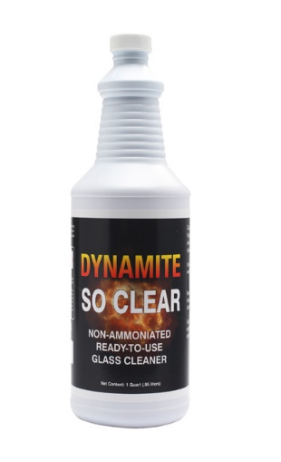
- For use on automotive windshields, plastics, and Plexiglas® .

Physical Form Color
Scent
Density/Specific Gravity pH 1% Solution

Liquid
Red
Solvent Odor
.0995
10.7

WARNING:
Causes eye irritation.
Keep out of reach of children.

SHIPPING WEIGHT IN POUNDS:
Case 12 Plastic Quarts 28.3 pounds

