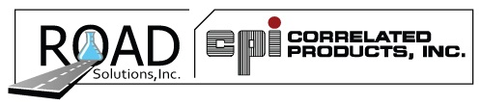
Molycor System
General Application Information

Single-axle dump truck with moderate rust, treating the underbody only
½ Gallon Molycor Plus
½ Gallon Arrest
1 Quart Clion
Double-axle dump truck with moderate rust, treating the underbody only:
¾ Gallon Molycor Plus
1 Gallon Arrest
2 Quart Clion
To include the dump body for the single-axle truck, add:
½ Gallon Molycor Plus
½ Gallon Arrest
1 Quart Clion
To include the dump body for the double-axle truck, add:
1 Gallon Molycor Plus
1 Gallon Arrest
2 Quarts Clion X

Treatment quantities vary depending on the size of the truck and the amount of rust being treated or removed.
Invite our regional manager in to show you how easy it is to use these products.
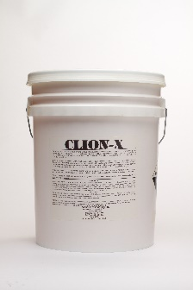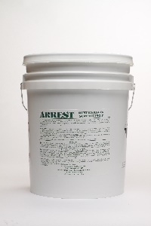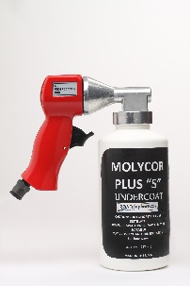
CLION-X SALT & CHLORIDE WASH ARREST-RUST REMOVAL/ MOLYCOR UNDERCOAT
COVERSION

5616 Progress Road
Indianapolis, IN 46241
317-243-3248*800-428-3266
www.CPIRoadSolutions.com

